
Instructions for Volunteers on Visual-Making
Materials:
- scissors use separate ones for cutting Velcro as it is sticky,
- A4 sheet of printed visuals,
- 80 micron laminating sheets,
      - laminator,
      - Velcro
      - plastic storage box

- Cut out each visual. Cut directly to the black border, leaving only a little excess white edge.

- Leave 1 sheet of printed visuals not cut out. This will help you to remember the order in which you need to place the visuals in the storage box/folder.

- Place visuals inside a laminator sheet. Make sure each visual has enough space around it for you to cut it out later.
TIP: If you find it easier, you can use a tiny amount of glue to hold the visual in place on the laminated sheet.
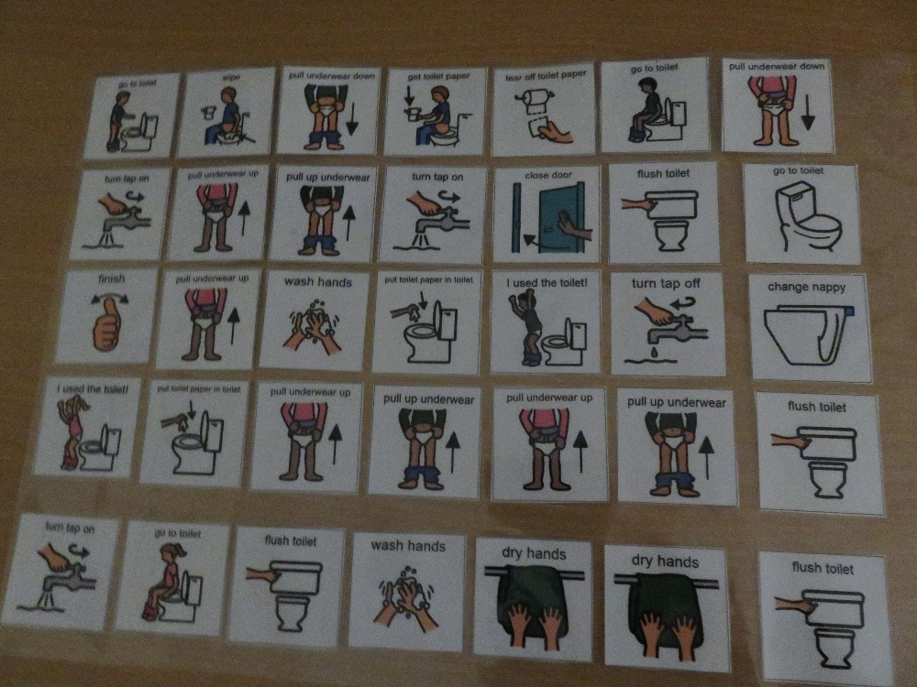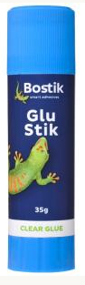

- Once you have folded the laminating sheet over the visuals, smooth your hand gently across it. This will lock the visuals in place and stop them moving when you place the sheet into the laminator.

- Feed the sheet into the laminator, ensuring to place the sealed edge first.
TIP: Make sure the laminator is hot or it will crinkle the visuals

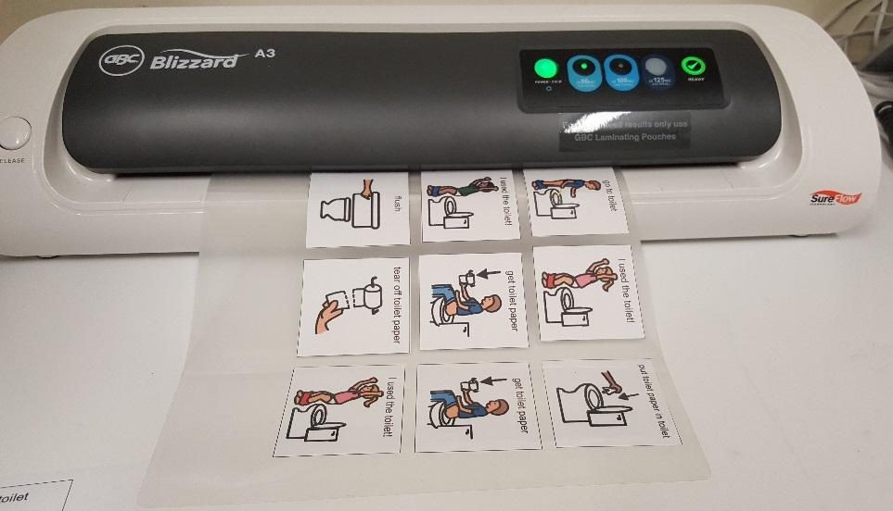

- Cut around each visual. Leave a 1mm border of laminate around the visual.

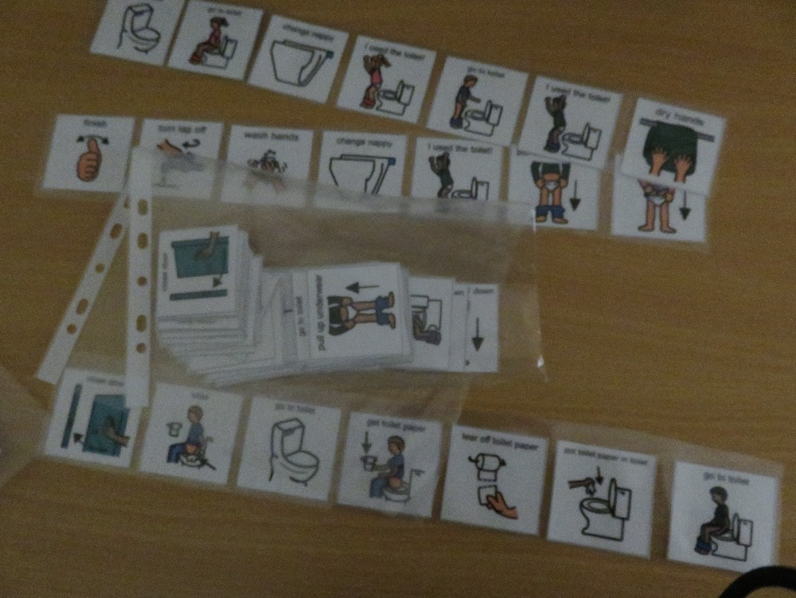

- Cut out a small piece of rough/ pricky Velcro. Attach this to the back of the visual. Ensure you use the scissors designated for cutting Velcro, otherwise you will blunt your paper scissors.
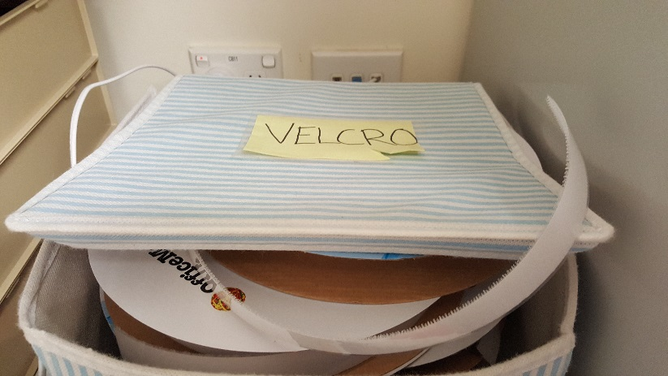
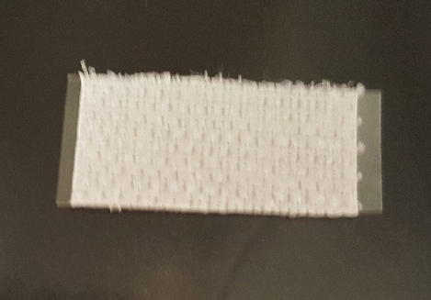

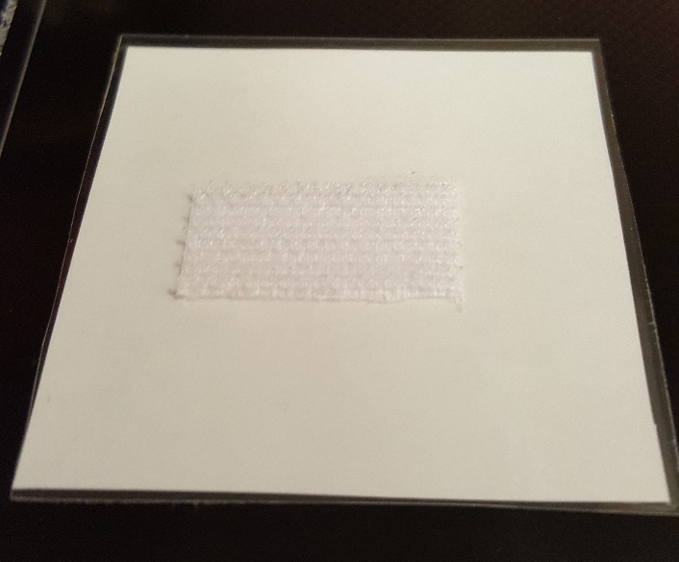
Suggested size for a guide

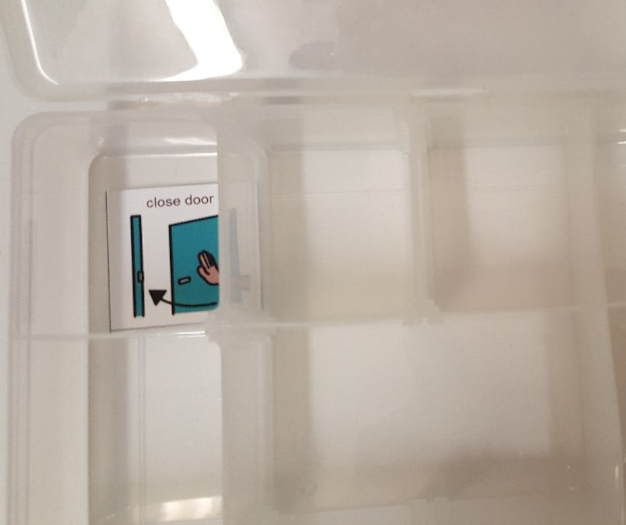
- Place the laminated visuals into the separate compartments of the storage box/folder. Use your 1 uncut sheet of visuals as to the order in which they should go into the box.

