
Instructions for Volunteers on Visual-Making
Needed Materials:
- Scissors. Have 2 pairs
- use separate ones for cutting Velcro as it is sticky,
- An A4 sheet of printed visuals,
- 80 micron laminating sheets,
      - laminator,
      - Velcro
      - plastic storage box

- Turn on laminator
- Look at printed visual sheet. Check out 1 column/ row, that you will leave uncut. This will help you to remember the order in which you need to place the visuals in the storage box/folder.

- When cutting on printed visual sheet cut out each visual. Cut directly to the black border, leaving only a little excess white edge.

- Place each cut out visual inside a laminator sheet. Make sure each visual has enough space around it for you to cut it out later. (See photo)
TIP: If you find it easier, you can use a tiny amount of glue to hold the visual in place on the laminated sheet.
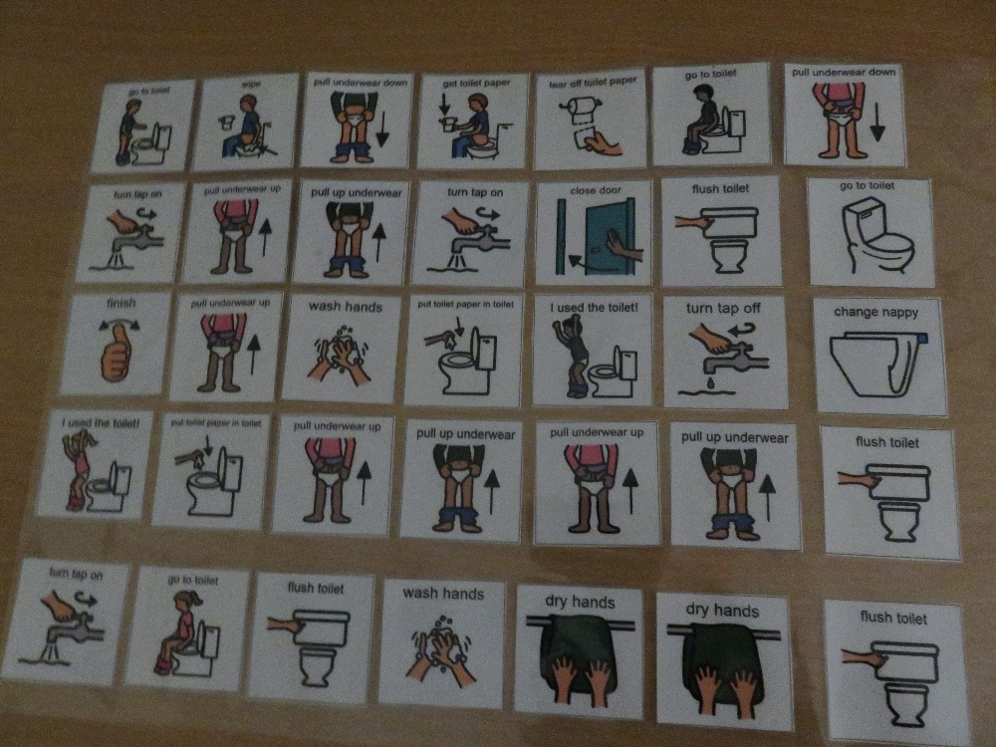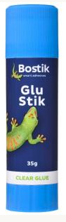
- Once you have folded the laminating sheet over the visuals, smooth your hand gently across it. This will lock the visuals in place and stop them moving when you place the sheet into the laminator.

Make sure the laminator is at the correct heat.
TIP: Make sure the laminator is hot or it will crinkle the visuals
- Feed the sheet into the laminator. Make sure to place the sealed edge in first.
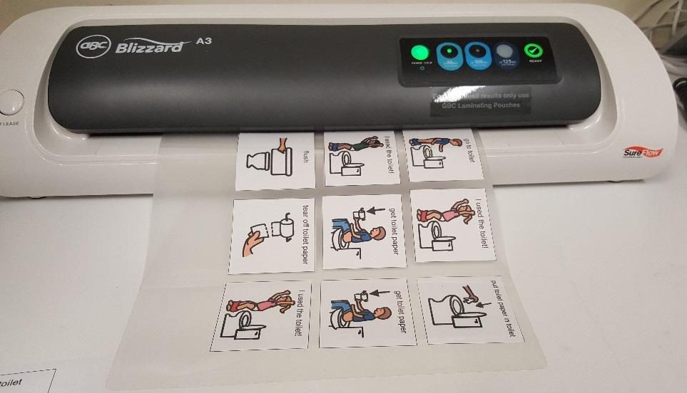
- Cut around each visual. Leave a 1mm border of laminate around the visual.

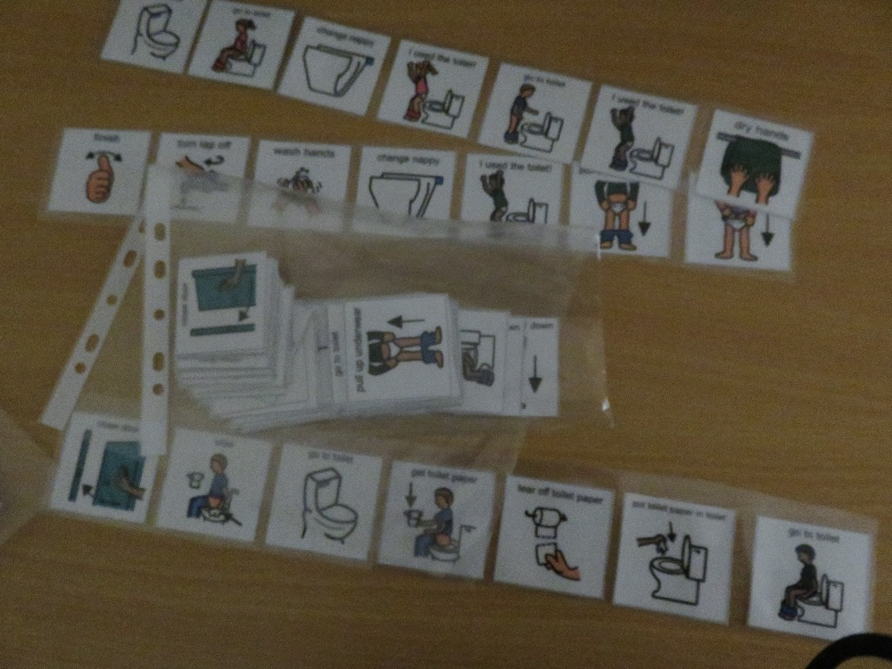
7.Cut out a small piece of rough/ pricky Velcro. Attach this to the back of the visual. Ensure you use the scissors designated for cutting Velcro, otherwise you will blunt your paper scissors.
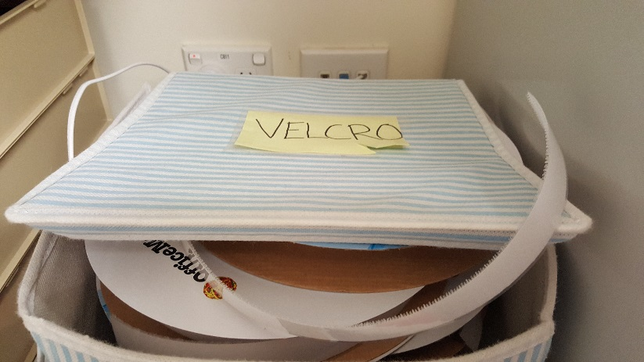
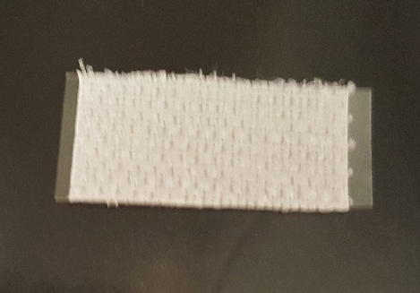

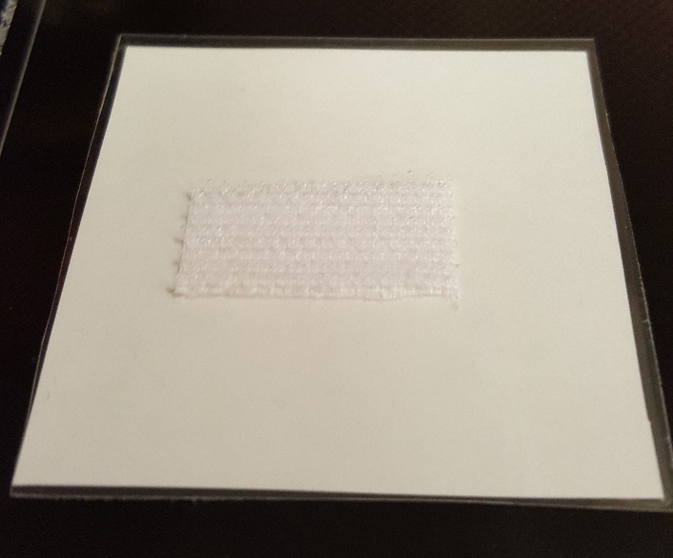
Suggested size for a guide.
Put laminated visuals into the plastic storage boxes.

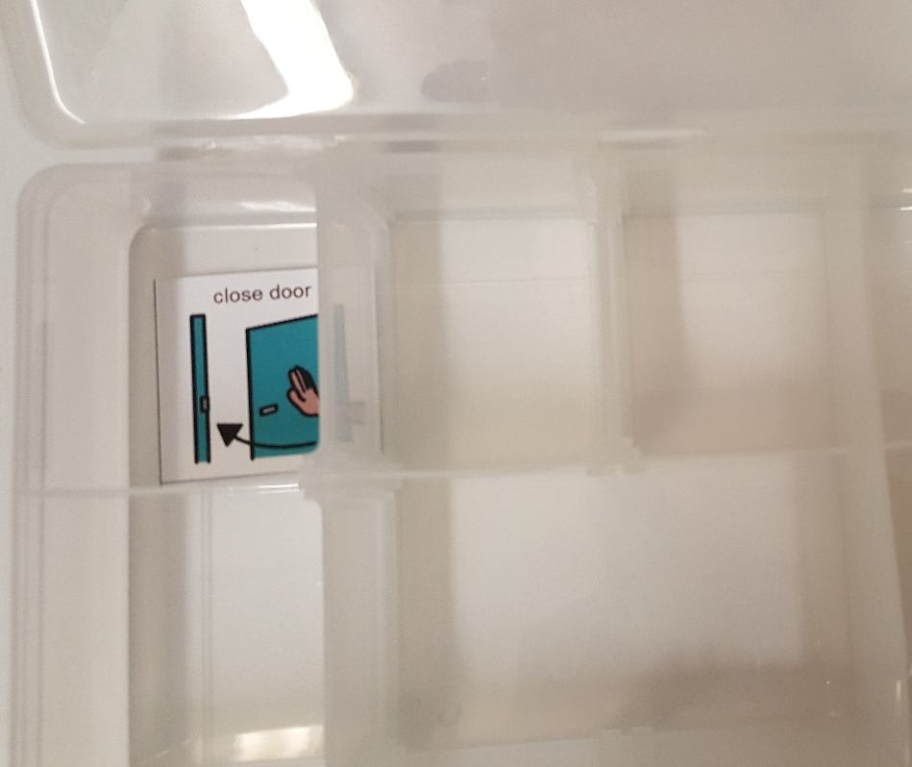
- Place the laminated visuals into the separate compartments of the storage box/folder. Use your 1 uncut sheet of visuals as to the order in which they should go into the boxx.

